**Lab 1: Error Analysis and Orientation**

***Team 10***

***James Kan, Amari West, Luke Morgan, Gabe Moreno***

**Texas A&M University**

College Station, 77843, US.

***Abstract*** *The length, width, and area of a wooden square was measured in pixel units by using a digital camera and a set of trackers. The coordinates of the trackers were then used to mathematically calculate the distances measured within each frame. Uncertainties are then propagated from the calculations via two methods.*

***Keywords:***

1. **Introduction**

The objective of this lab was to calculate the area of a square in square pixels while propagating an uncertainty, using an optical camera and two methods of calculation. This process demonstrated how taking multiple measurements of a physical object can create a form of ambiguity within the extracted data. Since measured quantities can never be truly exact or have infinite precision, measurements had to include an uncertainty based on the small random variations present during the series of data collection. Moreover, the experiment was designed to reveal how random errors can occur and affect the overall process when multiple samples of data are taken.

1. **Experimental Procedure**

**A. Description of Experimental Arrangement**

A personal laptop was connected to the side of the platform, which mainly consisted of a level, plastic surface with a grid-like assortment of small holes, from which air constantly flowed onto the surface - creating a sort of air cushion for the relatively lightweight, wooden square panel - limiting the coefficient of friction between the panel and the platform to become virtually non-existent, allowing for the panel to rotate quickly for an extended period of time, and allowing for a multitude of data points to be captured on three corners of the square (indicated by neon-yellow, green, and pink stickers).

The side of the platform contained an interface a variety of electronic and mechanical components, allowing the student to activate the air flow of the table and connect a personal device to the platform. Situated approximately half a meter (½ m) above the table was a small camera connected to the base of the platform, allowing for captures of up to 30 fps. However, the field of vision was confined to only the center region of the platform.

**B. Procedure** (see [here](https://tamu.blackboard.com/bbcswebdav/pid-6307291-dt-content-rid-57306992_1/courses/ENGR.216.2011.M4/216_lab_1%281%29.pdf) for complete and specific instructions)

A personal laptop with a Linux Secure Shell Terminal (e.g. MobaXterm) and an ethernet connection was required to capture the data and the recording of the experiment. Once connected and activated, the required terminal commands, and other commands needed in order to capture and record the data acquired from the camera were inputted. To capture the experiment, the wooden panel with the sticker side up was spun while recording. The panel in question always remained within the field of vision of the camera, or another trial was recorded. Recordings lasted for at least 30 seconds (~900 frames) to ensure adequate data points.

Once the requisite data was acquired, the data, recording, and all other pertinent files were saved to the personal device. The apparatus was then deactivated.

The initial data extracted from the procedure was in the form of a .csv file that listed the coordinates of the three points of the square for each individual frame. Finally, several calculations were done to find the width, length, and area as well as the uncertainties.

1. **Results**

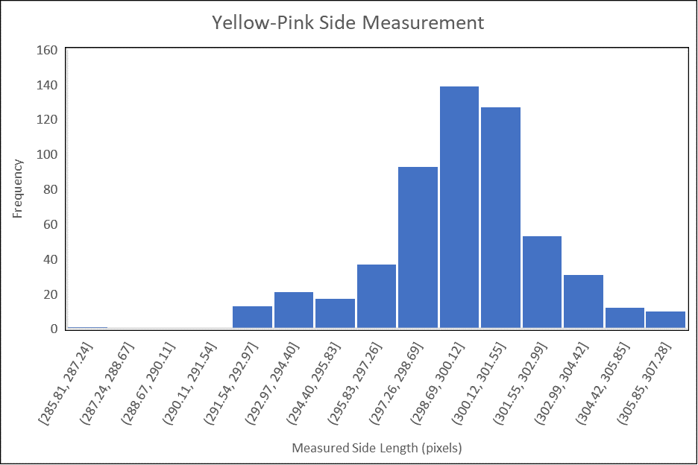

Figure 1:  Histogram of the distribution of side lengths measured by the camera for the Yellow-Pink side.

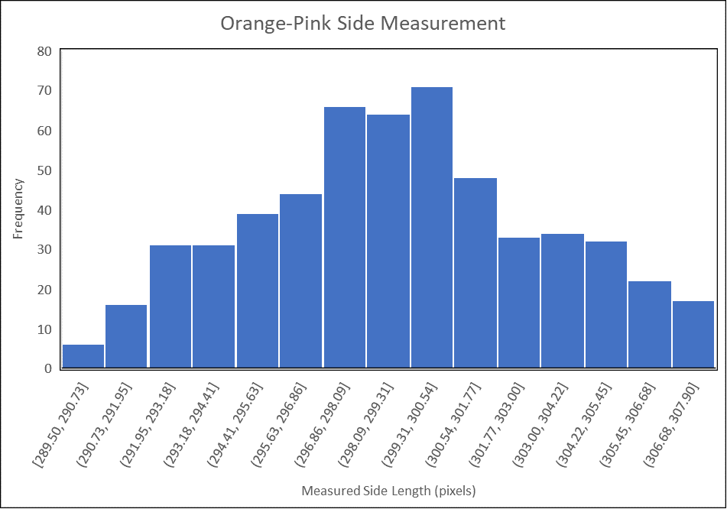

Figure 2: Histogram of the distribution of side lengths measured by the camera for the Orange-Pink side.

The side length measured by the camera for the Yellow-Pink side of the square was 299.6 pixels with an uncertainty, calculated by finding the standard deviation, of 2.83 pixels. The side length measured by the camera for the Orange-Pink side of the square was 299.0 pixels with an uncertainty, calculated by finding the standard deviation, of 4.09 pixels. The area of the square as calculated by multiplying the average measured length and the average measured width of the square was 89555.3 pixels with an uncertainty, calculated from the propagation of error formulas, of 1489.04 pixels. The area was also calculated by averaging the area calculated from each set of lengths and widths. This method of calculating the area

resulted in 89554.5 pixels with an uncertainty calculated by finding the standard deviation of the mean to be 61.36 pixels.

1. **Conclusions**

Based on the calculations and the propagated uncertainties, the most accurate measurement for area was likely 89554.5 ± 61.36 pixels